CSC 3210

Computer Organization and Programming

Lab 6

Answer Sheet

Student Name: Tracy Michaels

Section:

Lab 6(a)

Debug through each line of instructions.

Take screenshot that includes code and register window.

Record the register content.

and explain the register contents. (4 points)

Line number: 19

Instruction: mov ebx, Yval

Register values: EBX = 0000001E

Screenshot: 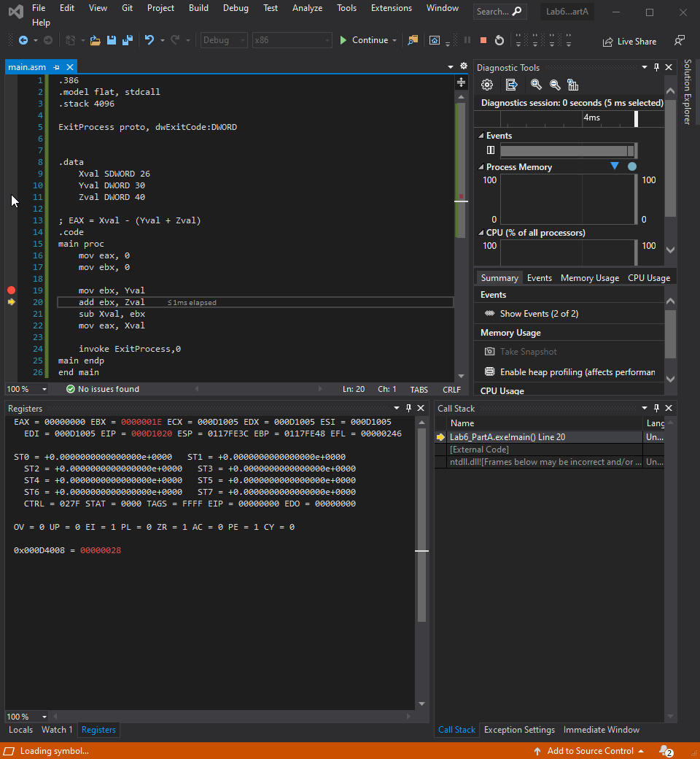

Explanation: takes the contents stored in the variable Yval and stores it into the BL section of the EBX register

Line number: 20

Instruction: add ebx, Zval

Register values: EBX = 00000046

Screenshot: 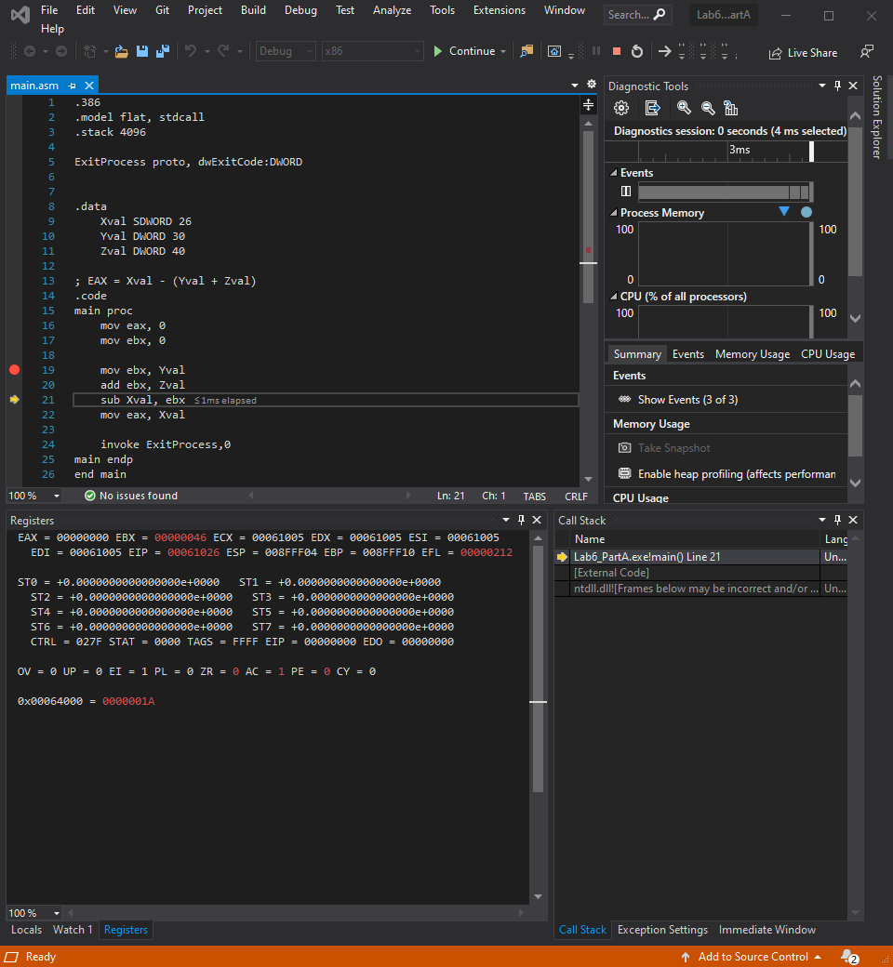

Explanation: adds the value in the Zval variable to the contents in the EBX register in this case it adds dec 40 to dec 30 and results in hex 46 stored in BL of the EBX register

Line number: 21

Instruction: sub Xval, ebx

Register values: no change

Screenshot: 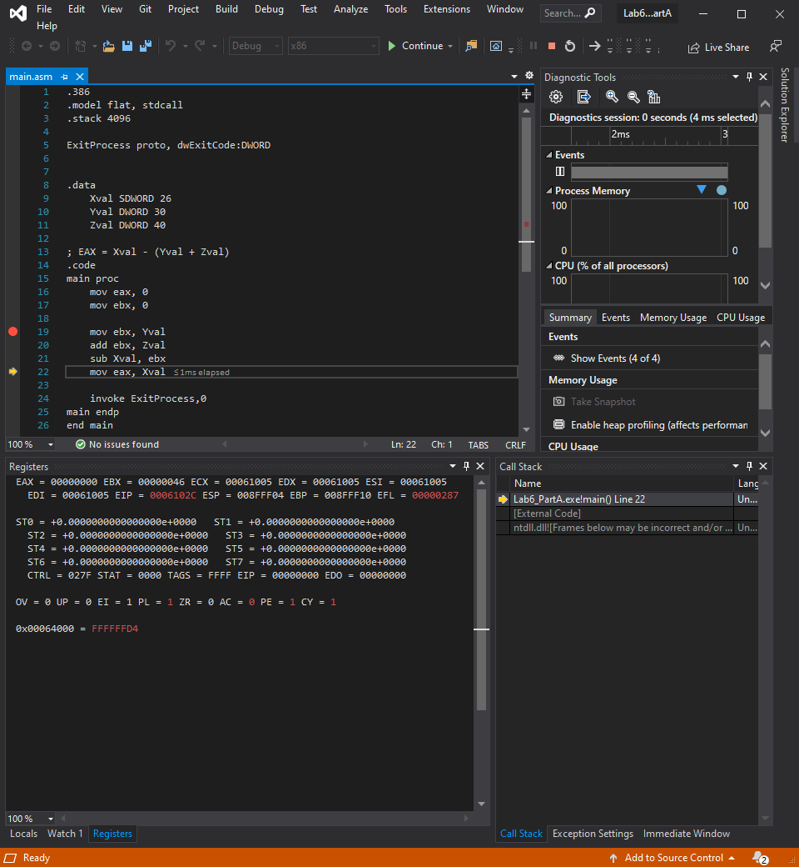

Explanation: this instruction is subtracting the value stored in the EBX register from the value stored in the variable Xval, since Xval is smaller than the value in bl and since it is a signed double word the value of Xval becomes hex FFFFFFD4

Line number: 22

Instruction: mov eax, Xval

Register values: EAX = FFFFFFD4

Screenshot: 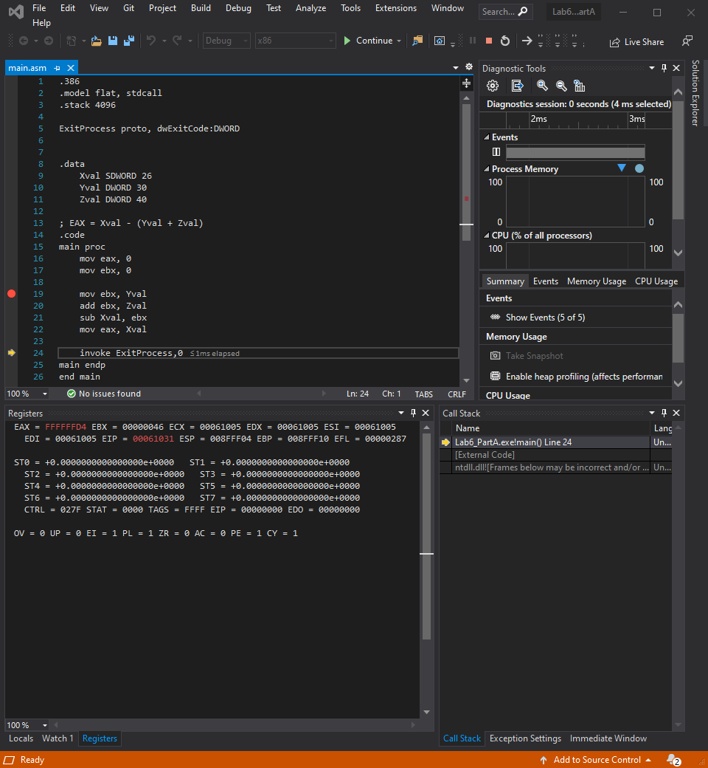

Explanation: this moves the new value that is stored in Xval into the register EAX

Lab 6(b)

1. What is the total size of the myWord array? (1 Point)

* 40 Bytes

1. Debug the code until the ‘invoke ExitProcess, 0’. Attach screenshot showing the content of AX register. (2 points)

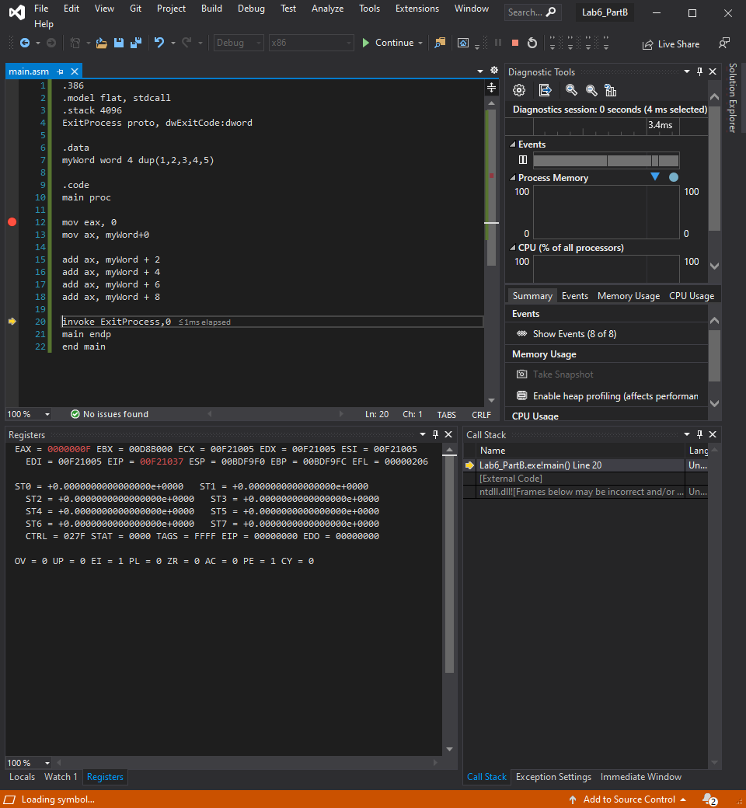

Lab 6(c):

1. What is the difference between symbolic constant and variables? (1 point)

* A symbolic constant can not change during runtime and does not reserve storage

1. Debug the code until ‘invoke ExitProcess, 0’. Attach the screenshot showing the content of al register. (2 points)

